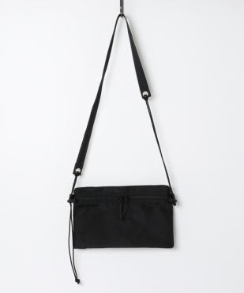 420D UTILITY SUCK (M)

主要特色：
使用420D PACK CLOTH NYLON，高密度，具防潑水效果，輕量， Outdoor適合。有三層收納夾層，方便存放隨身物品。此寬中型大小，也很適合女生背戴。

前口袋： 開口寬約24.5cm，7cm的底部擴充空間，雙拉鍊，可放重要物品。

中心口袋： 開口寬約29cm，壓扣，適合放置需常取出的次要物品。

後口袋： 開口寬約29cm，7cm的底部擴充空間，無拉鍊扣環，方便隨時拿取物品。

肩帶： 寬度為3mm的主軸繩，寬度為2.5cm的安全帶編織帶的組合，繩索長度可在74~128cm之間調節。

材質: 外部420D PACK CLOTH尼龍，內襯抗撕裂尼龍
尺寸: 寬28.0cm 高17.5cm 深7.0cm
重量: 135公克
產地: 美國布料，日本生產

The body uses 420 denier pack cloth nylon. It is a outdoor model with a combination of three layers of storage space and an easy-to-adjust shoulder strap. The medium size is suitable for women as well.

The main compartment is a snap button opening and closing. There is a zip pocket on the front, and it is safe even if things increase slightly with gussets. On the back is an open pocket, you can take your things out easily.

The strap can be adjusted from 74 to 128cm.

Material: 420D Pack Cloth Nylon
Size: W 28.0cm x H 17.5cm x D 7.0cm
Weight: 135g
Made In Japan using American fabric

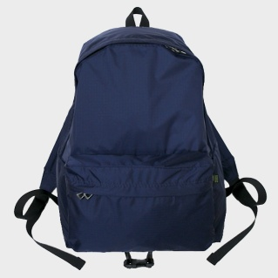 70D DAY PACK LIGHT

使用70丹的抗撕裂尼龍面料，輕量材質，配上4.5cm寬，0.7cm厚的肩帶，讓您可以輕鬆出門無負擔。

材質: 70D RIP STOP尼龙。
尺寸: 寬30.5cm 高40cm 底寬13.5cm
重量: 260公克
產地: 美國布料，日本生產

Using 70D rip stop nylon material, it is a light weight model, so you can wear it easily for outdoor activities.

Material: 70D Rip Stop Nylon
Size: W 30.5cm x H 40cm x Bottom 13.5cm
Weight: 260g
Made In Japan using American fabric

