# Mermaid Signet RingMermaid Signet Ring

**This mermaid design on the face of the ring was inspired by an old sailors tattoo. The ring is entirely carved by hand, with a brass face set in a solid silver ring. The side detail is a classical paisley design inspired by a floral pattern.**

**The ring is on the large side, aprox 1 inch x 3/4 inch and has a nice weight to it. The face is brass and the ring is solid silver.**

**LHN Jewelry Is Dedicated To Designing Hand Crafted, Artful Pieces Of Jewelry And Accessories. All The Pieces Are Proudly Made In Brooklyn, New York.**

**Ring Size: 8, 9, 10, 11**

**Mermaid： aprox 2.3 X 2.5cm**

**Side: aprox 0.5～2.5cm**

**Made in USA**

**美人魚，靈感來自一位老水手身上的紋身，側面則是以渦紋圖騰環繞，整枚戒指都以手工雕刻而成，正面為銅，側面為銀。**

**戒圍: 8, 9, 10, 11**

**美人魚：約2.3 X 2.5cm**

**側面: 約0.5～2.5cm**

**美國製**

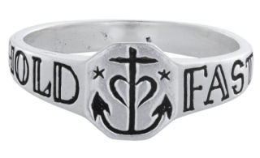

*Hold Fast Anchor Ring*

**In years past, ﻿Sailors would get the phrase "HOLD FAST" tattooed across their fingers. It was a reminder to stay vigilant in gripping the rigging of the ship. Without grasping the ropes firmly, a sailor could let a ship get off course or be himself swept overboard by wind or wave.**

**A symbol of strength - the anchor holds down ships even in the stormiest of weather. A heart is engraved around the anchor with two nautical stars on the face of the ring. "Hold Fast" is engraved on the sides.**

**The face measures approximately 1/4 x 1/4 inch.**

**LHN Jewelry Is Dedicated To Designing Hand Crafted, Artful Pieces Of Jewelry And Accessories. All The Pieces Are Proudly Made In Brooklyn, New York.**

**Size: 6,7,8,9,10**

**Front Diameter：Approximately 0.8~0.9cm**

**Side width：Approximately 0.25cm**

**Made in USA**

**早期，水手們會在手指頭紋上”Hold Fast(抓緊)”，目的在無時無刻提醒自己，要保持警惕抓住船的索具，不被風浪沖走。**

**力量的象徵 - 在暴風雨的天氣，船錨總能保持船隻穩定。 錨的周圍刻有一顆心，在戒指的表面上有兩顆航海星， 兩側刻有“Hold Fast”。**

**戒圍: 6,7,8,9,10**

**正面直徑：約0.8~0.9cm**

**側面寬度：約0.25cm**

**美國製**

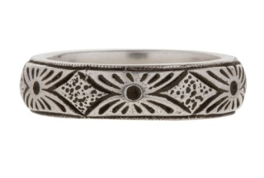*Yates Ring*

**Hand engraved with a diamond shape design, the style and aesthetic is reminiscent of an old English medieval design.**

**The ring is made from solid sterling silver, the ring is also ideal for a men's wedding band.**

**LHN Jewelry Is Dedicated To Designing Hand Crafted, Artful Pieces Of Jewelry And Accessories. The Designs Are Inspired By Antiquity And Historic Artifacts. All The Pieces Are Proudly Made By Hand In Brooklyn, New York.**

**Ring Size: 9,10,11**

**Width：Approximately 0.5cm**

**Made in USA**

**設計靈感來自古代和歷史文物，以手工雕刻出鑽石設計的紋路，讓人想起古老的英國中世紀風格與美感。戒指由純銀製成，也很適合作為男士結婚戒指的完美選擇。**

**戒圍: 9,10,11**

**寬度：約0.5cm**

**美國製**

 Lucky Charm Necklace

**The Lucky Charm Necklace from LHN is hand-cast & carved in Brooklyn, New York. Simple, cross fingers design for only the best of luck.**

**Pendant: 2.5cm x 1.7cm**

**Chain: 60cm**

**Made in USA**

**手工鑄造和雕刻出簡單的交叉的手指設計，為佩戴者帶來好運。**

**墜子: 長約2.5cm，寬約1.7cm**

**鍊子: 約60cm**

**美國製**