商品照片  Photo | 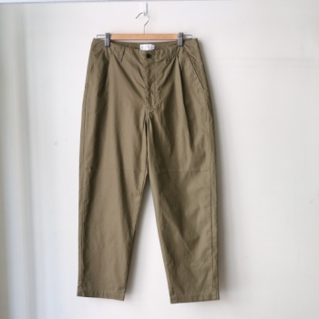
编号 No. | PT06203
名称 Name | Supima Cotton Gabardine Tapered Pants  皮马棉华达呢宽松打褶长裤
介绍  Description | Loose pants, a design that can be found in the past couple seasons of Still By Hand. The pants are with tapered silhouette which is comfortable and breathable when wearing and also figure flattering. Smooth and elegant fabric, made of Gabardine woven from American Supima cotton. Although the texture is tight, but the hand feeling is soft and smooth.  宽松裤型，上宽下窄的锥形剪裁，舒适透气，修饰身型。光滑的面料，带着优雅氛围，主要使用美国皮马棉(Supima)织成的华达呢斜纹面料(Gabardine)制成，面料结构密实，但确相当柔软光滑。
材质  Material | 100% Cotton  100% 棉
产地  From | Made in Japan  日本制
尺寸参考  Size’s Ref. | 男模特：176cm/70kg，着46  The male model is 176cm/70kg and wears size 46

商品照片  Photo | 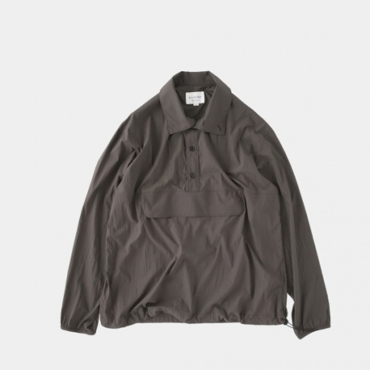
编号 No. | BL01203
名称 Name | Lightweight Portable Anorak
介绍  Description | Made of lightweight material, the fabric is water resistance and with a washed feeling.  With buttons, easy to put on and take off.  There is also a large pocket on the abdomen.  Lightweight and foldable, you can put it in your bag, which is very suitable for autumn.  采用轻量材质制成，透过特殊处理了增加面料的防水及抗水性，并带着些微水洗感。  钮扣排扣，方便穿脱。  腹部还有一个大口袋设计，轻巧可折迭，可随身放入包包，很适合入秋后的多变气候。
材质  Material | 100%Polyester  100%涤纶
产地  From | Made in Japan  日本制
尺寸参考  Size’s Ref. | 男模特：176cm/70kg，着48  The male model is 176cm/70kg and wears size 48

商品照片  Photo | 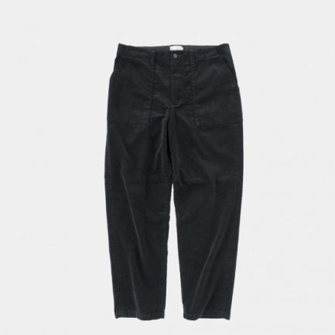
编号 No. | PT03203
名称 Name | Corduroy Pants
介绍  Description | Corduroy fabric is from a famous British fabric company named “Brisbane Moss” .  The point of the design is the pocket that straddles the side line.  The slightly loose tapered silhouette can make you look more mature and staidness when wearing. It is a perfect pants for for autumn / winter.  粗灯芯绒来自于历史悠久的英国面料供货商(Brisbane Moss)，面料扎实，能够反复穿着的经典秋冬单品。设计的重点是横跨边线的大口袋。略微松散的锥形剪裁，适合秋冬搭配。
材质  Material | 100% Cotton  100%棉
产地  From | Made in Japan  日本制
尺寸参考  Size’s Ref. | 男模特：176cm/70kg，着46  The male model is 176cm/70kg and wears size 46.

商品照片  Photo | 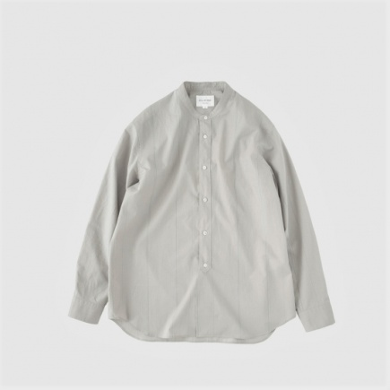
编号 No. | SH05203
名称 Name | Band Collar Striped Shirt
介绍  Description | 采用STILL BY HAND的经典面料制成，以灰蓝色交织出细腻的线条。偏长的衣长设计，更显轻松休闲风格。  The band collar stripe shirt is made of the classic fabric from Still By Hand and striped with Grey and blue. The length of the shirt is longer than usual to create a more relax style.
材质  Material | 100% Cotton  100%棉
产地  From | Made in Japan  日本制
尺寸参考  Size’s Ref. | 男模特：176cm/70kg，着48  The male model is 176cm/70kg and wears size 48

商品照片  Photo | 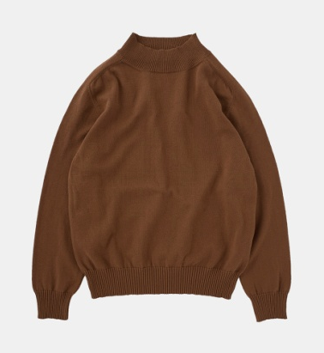
编号 No. | KN07203CM
名称 Name | Turtleneck Knitwear Camel
介绍  Description | With a variety of cotton called Aspero, which is the raw material for bells.  A medium-sized cotton knit.  Only a wool-like touch can be washed with Picotton. The feeling of the neck that does not squirm is also a point  采用多种棉料混合织成，称为” Aspero”阿斯佩罗。  中厚度型棉质针织衫。  带着跟羊毛面料一样的触感，宽大的脖围设计，舒适不束缚。
材质  Material | 100% Cotton  100%棉
产地  From | Made in Japan  日本制
尺寸参考  Size’s Ref. | 男模特：176cm/70kg，着48  The male model is 176cm/70kg and wears size 48.

商品照片  Photo | 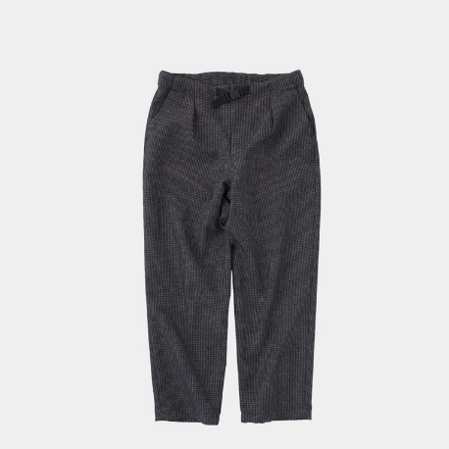
编号 No. | PT0520
名称 Name | Plaid Tweed Trousers Charcoal Check
介绍  Description | A fabric that looks like tweed without the use of wool  Using a tweed-like texture woven with a special polyester thread.  It has an appropriate thickness and firmness, and it has a texture reminiscent of wool.  Despite its appearance, it has the advantages of polyester, which is robust and easy care  With a moderately spacious, gently tapered silhouette of medium thickness, it is a shape that can be matched with any tops.  In particular, it is an excellent match for coordination in the fall / winter season when the volume comes out with outerwear and knitwear.  Look like climbing pants.  The waist is a webbing belt used for climbing pants.  使用如同羊毛般的特殊面料  带有特殊聚酯线的粗花呢样质地。带有厚度和硬度，触感如同羊毛的面料。但它却是聚酯纤维，然而优点比羊毛多许多，非常耐穿且容易于保养  带有登山裤的裤型，使用登山裤的腰带，中等锥形的逐渐变窄的剪裁，非常好搭配。
材质  Material | 100% Polyester  100%聚酯纤维
产地  From | Made in Japan  日本制
尺寸参考  Size’s Ref. | 男模特：176cm/70kg，着46  The male model is 176cm/70kg and wears size 46.

商品照片  Photo | 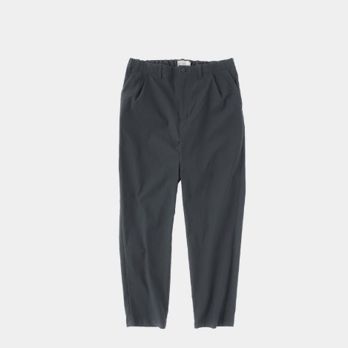
编号 No. | PT04203
名称 Name | Nylon and Wool Blend Tapered Pants Dark Teal
介绍  Description | Using a material that is overprinted with a pigment that changes over time when washed with the worsted wool material used for suits.  The product is washed with an awareness of creating a random surface.  The circumference is moderately loose and tapered, so it gives a neat impression.  Although it is made of 60% wool, it is a material that is easy to wear with almost no wool feeling.  使用一种用色料迭印的面料，此色料在用于西装的精纺羊毛面料，在多次洗涤后会随着时间而变化。  微宽松且锥形剪裁，尽管它拥有60％羊毛成分，但它在穿着上几乎没有羊毛面料的触感，非常的柔和舒适。
材质  Material | 40%Nylon+60%Wool  40%尼龙+60%羊毛
产地  From | Made in Japan  日本制
尺寸参考  Size’s Ref. | 男模特：176cm/70kg，着46  The male model is 176cm/70kg and wears size 46.

