商品照片  Photo | 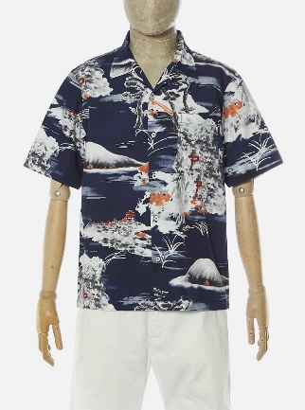
編號 No. | 24189
名稱 Name | Road Shirt In Navy Fuji Summer Print -Navy
介紹  Description | Our classic simple short sleeve summer shirt. Wear open-necked.  This particular fabric is sourced from one of our favorite Japanese mills.  Washcare: Wash at 30 degrees. Do not bleach. Do not tumble dry. Warm iron. Do not dry clean. Wash like colours together. Do not iron decoration.  經典的開襟短袖夏季襯衫，布料特別選自一家Universal Works喜愛的日本紡織廠，融入日本富士山插畫，充滿日式情。
材質  Material | 100% Cotton  100%棉
產地  From | Made in Portugal  葡萄牙製
尺寸參考  Size’s Ref. | The male clerk is 175cm/70kg and wears in size M.  男店員175cm/70kg著M

商品照片
Photo
編號 No. | 24190
名稱 Name | Chambray Summer Overshirt - Indigo
介紹  Description | Loose fit, straight cut overshirt with pockets.  Chambray is a plain weave fine fabric with alternating coloured warp and weft yarns that are woven together to form a soft, lightweight but durable cloth.  寬鬆版型，夾克襯衫，帶有多個口袋，工裝風格。  Chambray是一種平紋精細織物，以有色經紗和白色緯紗交織在一起，形成柔軟，輕便但耐用的布料。
材質  Material | 100% Cotton  100%棉
產地  From | Made in Portugal  葡萄牙製
尺寸參考  Size’s Ref. | The male clerk is 175cm/70kg and wears in size M.  男店員175cm/70kg著M

商品照片  Photo | 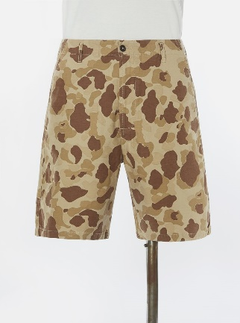
編號 No. | 24152
名稱 Name | Loose Short In Sand Peacekeeper Camo - Olive
介紹  Description | Loose, relaxed short with a knee-length fit.  This particular fabric is sourced from one of our favourite mills, based in Osaka, Japan. It has a soft, slubbed finish, and is based on an old US military design.  寬鬆剪材，及膝褲長，休閒風格的美軍風格短褲。  這種特殊的面料來自Universal Works最喜歡的日本大阪工廠，它具有柔軟，光滑的表面效果，並帶有復古美軍風格。
材質  Material | 100% Cotton  100%棉
產地  From | Made in Portugal  葡萄牙製
尺寸參考  Size’s Ref. | The male clerk is 175cm/70kg and wears in size 30.  男店員175cm/70kg著30

商品照片  Photo | 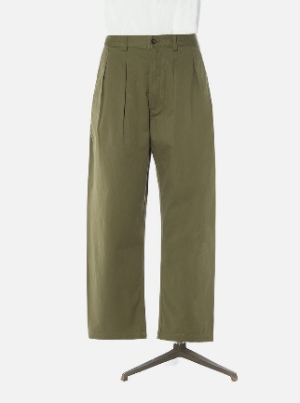
編號 No. | 00133
名稱 Name | Double Pleat Pant In Light Olive Twill – Light Olive
介紹  Description | 雙褶設計，寬鬆錐型剪裁，UW獨家面料，3/1斜紋編織。  Double pleat loose pant.  Exclusive UW fabric; 3/1 twill weave. 100% Cotton.
材質  Material | 100% Cotton  100%棉
產地  From | Made in Portugal  葡萄牙製
尺寸參考  Size’s Ref. | The male clerk is 175cm/70kg and wears in size 30.  男店員175cm/70kg著30

